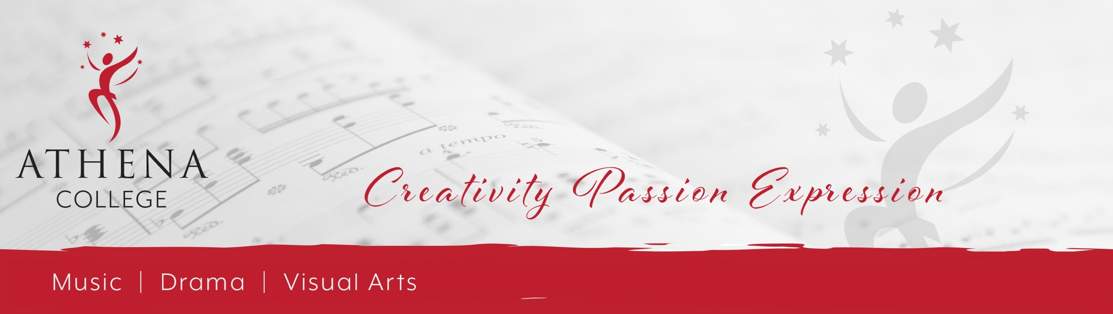
APPLICATION FORM – SPEECH AND DRAMA

Student Details:
Surname:______________________________ First Name:______________________________________
D.O.B:________________________________

Contact Details:
Surname:______________________________ First Name:______________________________________
Phone:________________________________ Email:__________________________________________
Address:_______________________________________________________________________________________________________________________________________________________________________
Postcode: ____________________

Has the student studied speech and drama before? (PLEASE CIRCLE) YES NO
If yes:
For how long? _____________________________________________
If the student has achieved any exam levels, which grades? (E.g. AMEB, Trinity, ANZCA, etc.)
_______________________________________________

Does the student wish to learn individually or in a small group?
PLEASE CIRCLE: GROUP INDIVIDUAL

How did you find out about us? _____________________________________________________________

Disclaimer:
I understand the terms and conditions as outlined in the “Speech and Drama Information Brochure” and would like to proceed with the application for study through your school. I understand that a place in the suitable area of my request may not be available straight away or possibly at all and that Athena College will keep my details on file for future correspondence.
Signed: _______________________________________ Date: __________________________________

